

LG B2050

Description
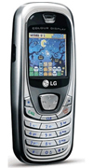
The ultra thin, strong and lightweight design makes the LG B2050 easily portable, no matter what the occasion. It has a high resolution 64k color screen and is set up (MMS enabled) for picture messaging, so it's easy to send and receive images.

STORE PRICE: Rs 1,874 /-
ONLINE PRICE: Rs 1,874 /-

Brand : LG
Model Name : B2050
Released Year : 2005
Phone Memory : 1.4 MB shared memory
External Memory : No
Colors : N/A
Form : Bar
Dimensions : 105 x 44 x 15.9 mm
Weight : 72 g

